User Interface (UI)

for

NASA Maestro Format Test Tool

**Version 2.0**

**Prepared by:**

**NASA TEAM 1**

**University of Maryland Global Campus**

**April 4th, 2020**

Table of Contents

1. Introduction 1

1.1 Purpose 1

1.1 Scope 1

1.2 Reference Document 1

1.3 Terms, Abbreviations, and acronyms 2

2. Graphical Interface Design 3

3. Support Pages 4

3.1 Header 4

4. Main Pages 5

4.1 Home 5

4.2 Compare DOCX Files 6

4.3 Convert Docx 7

4.4 Validate Docx 8

4.5 Results 9

**Authors**

* Alberto Bonfiglio
* Beatrice Oluwabuyi
* Jacquetta Reid
* Kenya Foster
* Rick Stuart
* Tiezheng Yuan

**Revision History**

|  |  |  |
| --- | --- | --- |
| Date | Reason for Update | Version |
| April 3rd, 2020 | Initial Version | 1.0 |
| April 25, 2020 | Updated UI Design | 2.0 |

# Introduction

## Purpose

This document defines the user interface (UI) design of the NASA Maestro Format Testing Tool (FTT). The customer requires updates to the Maestro software suite, which is a tool used at NASA to create procedures for spacewalks (EVAs). In general, these procedures include two astronauts working outside the space station, a robotics operator inside, and other actions taken by Mission Control on the ground. This software allows maestro to take the procedure data and can render it in many file types (HTML, DOCX, specific XML types) as well as different formats (EVA format, IVA format, etc.).

## Scope

This document is the graphical user interface design document for the software FTT. This document presents the UI design for the web version, which provides a unified outlook of the technical details on UI development in the phase of system implementation. All UI designs are consistent with requirements ruled in the requirements specifications of the project.

This document is written for stakeholders including system users, project managers, system designers, software developers, software tester, and system builders.

## Reference Document

1. Requirements specifications of NASA Maestro Format Testing Tool.

2. Project Plan of NASA Maestro Format Testing Tool.

## Terms, Abbreviations, and acronyms

|  |  |
| --- | --- |
| Word | Definition |
| Extravehicular Activity | Any activity that is done by an astronaut or cosmonaut outside a spacecraft beyond the Earth's appreciable atmosphere. |
| Intravehicular Activity | Any activity that is done by an astronaut or cosmonaut inside a spacecraft beyond the Earth's appreciable atmosphere. |
| NASA MAESTRO | An open-source program released by [NASA](https://en.wikipedia.org/wiki/NASA) to facilitate the creation of EVA and IVA procedures. |
| YAML | A [human-readable](https://en.wikipedia.org/wiki/Human-readable) [data-serialization language](https://en.wikipedia.org/wiki/Serialization). It is commonly used for [configuration files](https://en.wikipedia.org/wiki/Configuration_file) and in applications where data is being stored or transmitted. |
| .docx | A DOCX file is a document created by Microsoft Word or another [word processing](https://techterms.com/definition/wordprocessor) program, such as OpenOffice Writer or Apple Pages. It contains formatted text but may also include images, drawn objects, and other document elements. |
| Vector | A point that has a definite position on the x- and y-axis of the work plane and determines the direction of the path; further, each path may have various properties including values for stroke color, shape, curve, thickness, and fill. |
| GNU | An operating system that is [free software](https://www.gnu.org/philosophy/free-sw.html). The GNU operating system consists of GNU packages (programs specifically released by the GNU Project) as well as free software released by third parties. |
| YAML | A [human-readable](https://en.wikipedia.org/wiki/Human-readable) [data-serialization language](https://en.wikipedia.org/wiki/Serialization). It is commonly used for [configuration files](https://en.wikipedia.org/wiki/Configuration_file) and in applications where data is being stored or transmitted. |

|  |  |
| --- | --- |
| Abbreviation | Meaning |
| NASA | National Aeronautics and Space Administration |
| HUD | Heads-Up Display |
| EVA | Extravehicular Activity |
| IVA | Intravehicular Activity |
| HTML | Hypertext Markup Language |
| DOCX | Microsoft Word Document Format |
| XML | Extensible Markup Language |
| API | Application Programming Interface |
| CICD | Continuous Integration and Continuous Deployment |
| PM | Project Manager |
| CICD | Continuous integration and continuous delivery |
| PDF | Portable Document Format |
| REST | Representational State Transfer |
| UI | User Interface |

# Graphical Interface Design

This product will test Maestro’s ability to output the desired .docx format. The program will test whether the created file is a valid Microsoft Word document and shall be able to run on a non-windows system and without the use of Microsoft Word. Additionally, it will make the document into a PDF and then an image file (PNG or SVG) to allow pixel comparison with a previously generated expected outcome.

Additionally, XML creation will be tested in the Maestro software suite of outputs and the project will be ported to Gitlab. Furthermore, testing within Maestro will be automated using Runkit, and a system to track API changes will be added.

# Support Pages

The section describes the elements of UI shared by all pages.

## Header

* Screen Name: N/A
* Image:

**Internal UI functionality**:

* None

**External UI functionality**:

* The *Compare DOCX Files* link takes the user to the Compare DOCX Screen. See ____ for more information.
* The *Convert DOCX to a PNG* link takes the user to the Convert DOCX to PNG Screen. See _____ for more information.
* The *Validate DOCX* link takes the user to the Validate DOCX screen. See ____ for more information.

# Main Pages

## Home

* Screen Name: Home Screen
* Image:

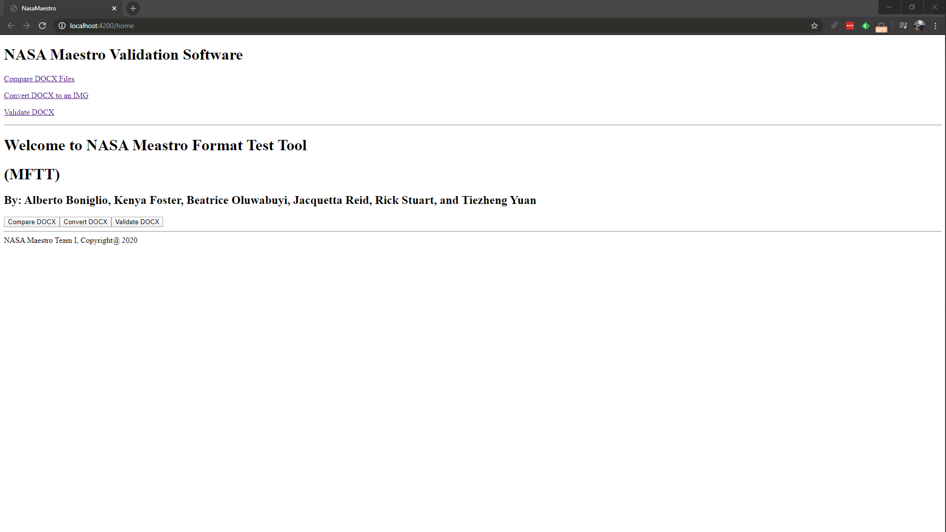

**Internal UI functionality**:

* None

**External UI functionality**:

* The *Compare DOCX Files* button takes the user to the Compare DOCX Screen. See ____ for more information.
* The *Convert DOCX to a PNG* button takes the user to the Convert DOCX to PNG Screen. See _____ for more information.
* The *Validate DOCX* button takes the user to the Validate DOCX screen. See ____ for more information.

## Compare DOCX Files

* Screen Name: Upload Docx
* Image:

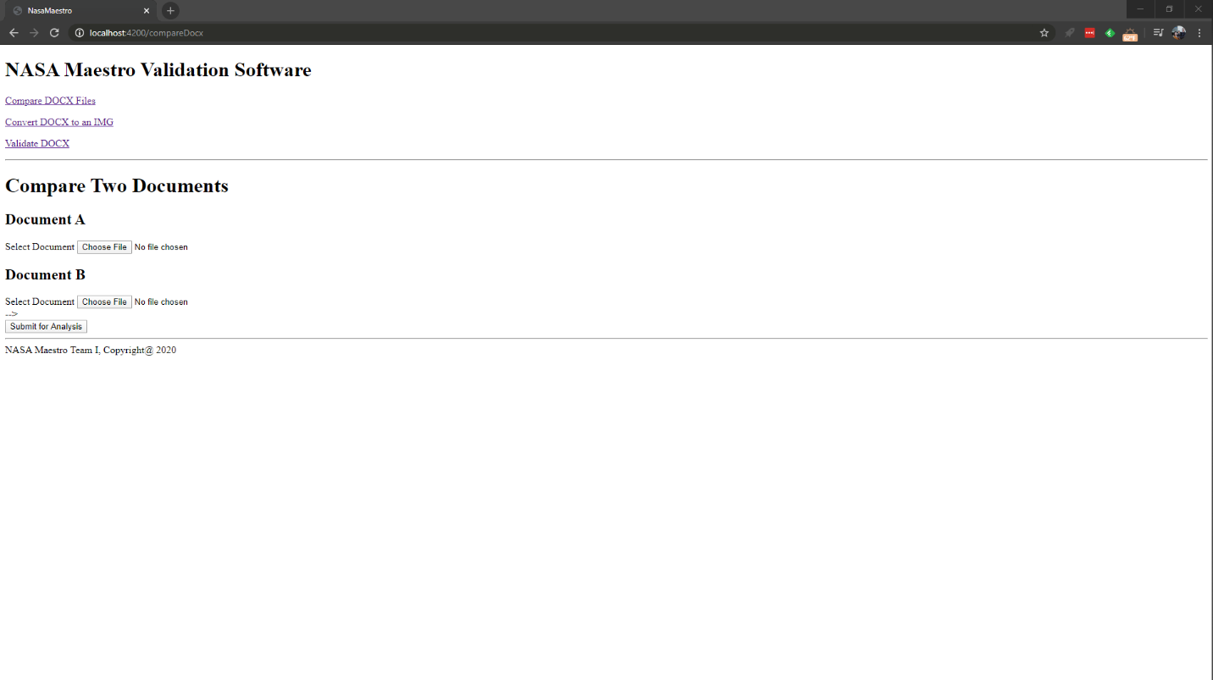

**Internal UI functionality**:

* The *Choose File* buttons allow the user to select two DOCX files for comparison. The button uses the browser's built-in file browser.

**External UI functionality**:

* The *Submit for Analysis* button sends an HTTP POST request to the docker backend and waits for the docker’s response. The user is then sent to the Results Page. See ____ for more information.

## Convert Docx

* Screen Name: Convert Docx
* Image:

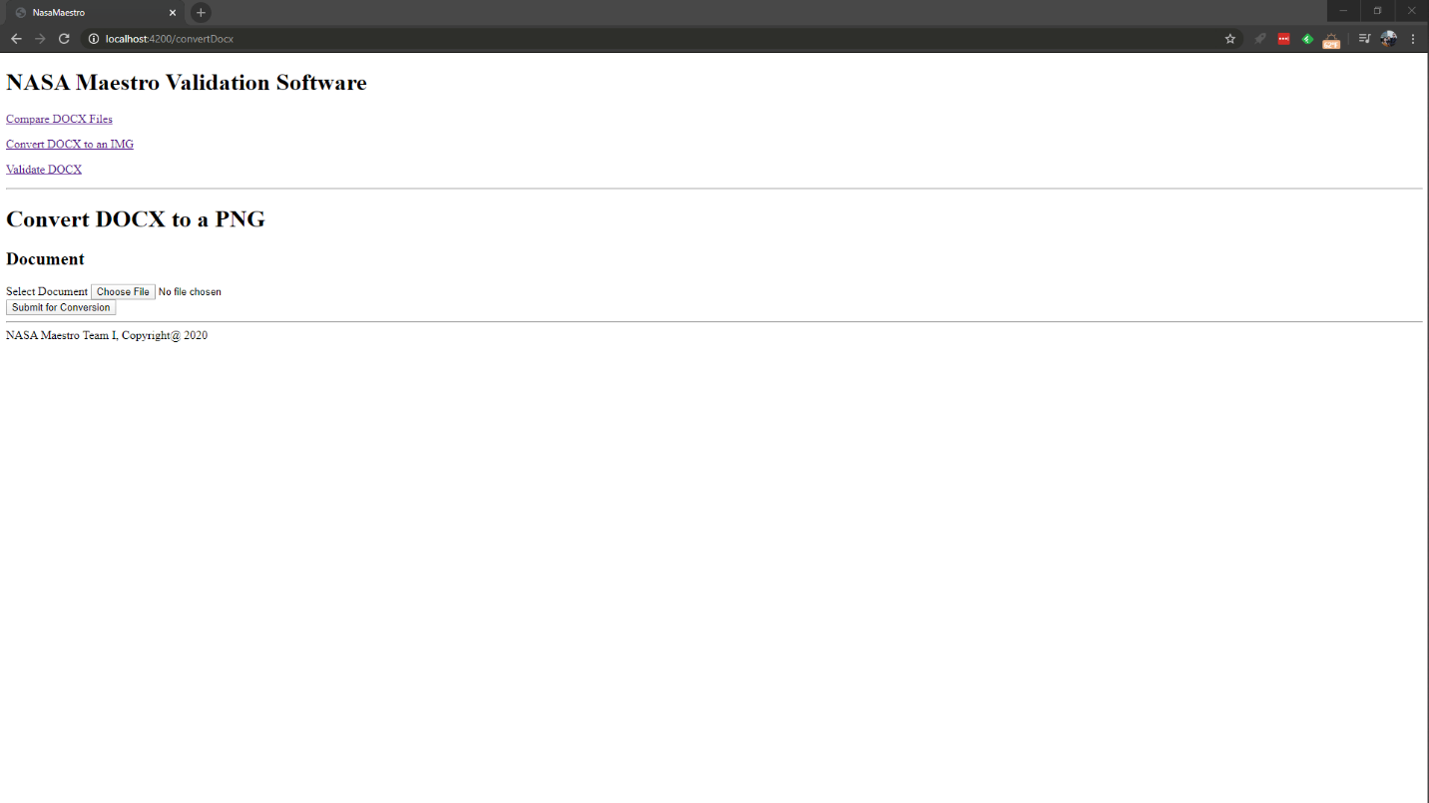

**Internal UI functionality**:

* The *Choose File* button allows the user to select a DOCX file for conversion. The button uses the browser's built-in file browser.

**External UI functionality**:

* The *Submit for Conversion* button sends an HTTP POST request to the docker backend and waits for the docker’s response. The user is then sent to the Results Page. See ____ for more information.

## Validate Docx

* Screen Name: Validate Docx
* Image:

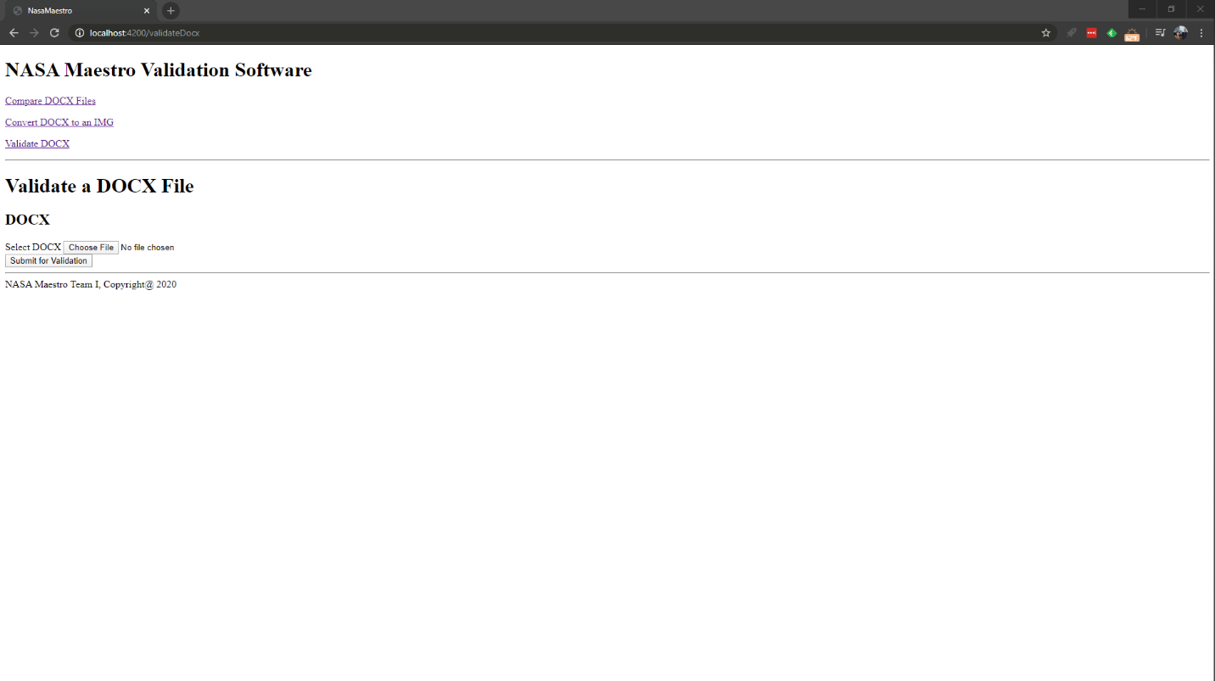

**Internal UI functionality**:

* The *Choose File* button allows the user to select a DOCX file for validation. The button uses the browser's built-in file browser.

**External UI functionality**:

* The *Submit for Validation* button sends an HTTP POST request to the docker backend and waits for the docker’s response. The user is then sent to the Results Page. See ____ for more information.

## Results

* Screen Name: Results Page
* Image:

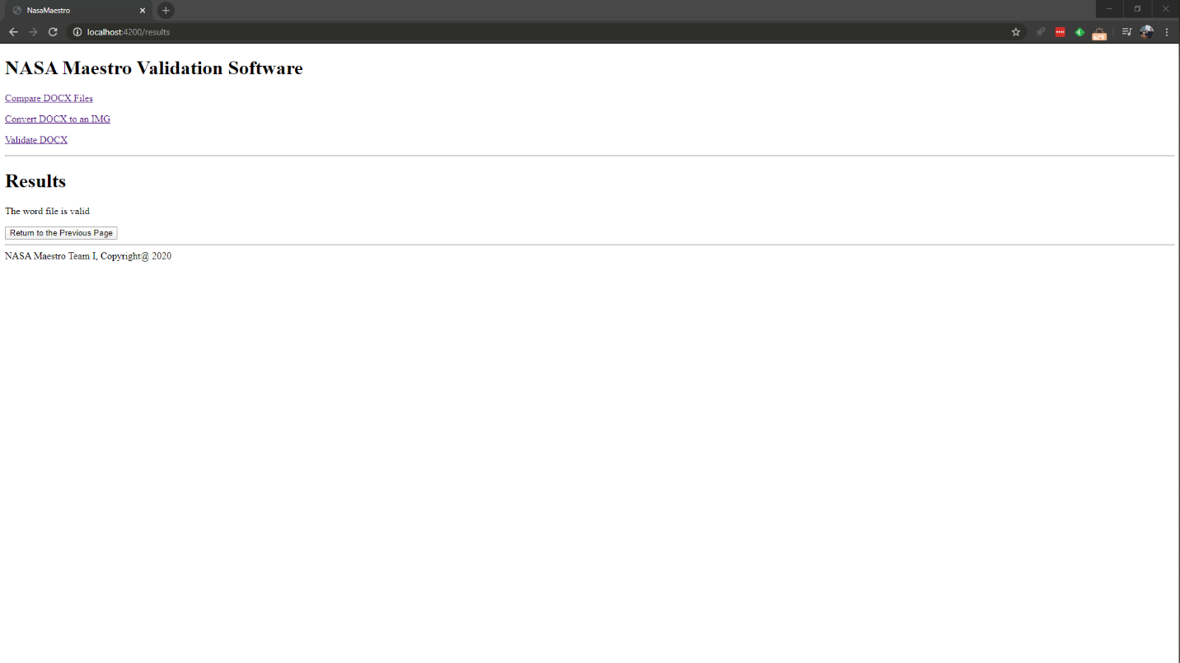

**Internal UI functionality**:

* For results that return a file, text with a URL is available for the user to download the image or images.

**External UI functionality**:

* The *Return to Previous Page* button returns the user to the page that sent the user to the results page.